Watts is the name I've chosen for this new rolling robot.

Watts is an in-the-world laboratory for exploring subsumption architecture fused with machine learning to produce emergent behaviors that are interesting to interact with for the humans in their world.

A subsumption architecture (Rodney Brooks) is layered behaviors that are able to stand on their own and are combined in a priority scheme that allows only one to control the behaviors of Watts at a time. Since Watts will evolve into presenting behaviors in multiple dimensions (movement, sound interaction, visual interaction) that will provide a rich playground for exploration of how a subsumption architecture can create interesting emergent behaviors.

Brooks demonstrated his ideas in a robot that included an Avoiding behavior, a Wandering behavior, and Exploring behavior and a Seeking behavior. These behaviors were directly sensing the world of the robot as it moved and they were given a priority scheme that chose one of them to control the motion of the robot. There is no representation of the world built into the robot's software. The robot uses the world itself as the model it tests its sensor inputs against. It implemented the basic functions as an augmented finite state machine (AFSM).

Minsky, in The Emotion Machine (2007), presents a hierarchy of intelligent behavior.

Self-Conscious Thinking
Self-Reflective Thinking
Reflective Thinking
Deliberative Thinking
Learned Behavior
Instinctive Behavior

In one review of his work, Brooks' subsumption architecture was assigned to satisfy learned and instinctive behavior, while earlier AI ideas (SOAR and General Purpose Problem Solving) were assigned to the Deliberative thinking layer. A new AI approach that uses language to guide perception and to describe events, eventually to tell and understand stories and to guide and understand culture (both in the macro society and micro personal realms) is an attempt to meet the needs and observed intelligence in Reflective, Self-Reflective and Self-Conscious thinking. This approach (GENESIS?) might be integrated into the Deliberative, Learned and Instinctive layers through a subsumption architecture, or there may be some other more useful way of fusing thinking into behavior.

For Watts to work as a laboratory, his internal workings must be observable. We need to understand his physical resources (CPU, memory, disk/file space, battery, bandwidth of streaming data) as well as the data streams itself, behavior sequences, subsumption arbitration events, and state changes in AFSMs. Some of the parts will be machine learning programs, evaluating models with input from one or more sensors, or from other parts. Each of them will have observable input and output logs.

The micro controller arbitration process takes the global outputs from each of the parts and performs a sequence of assignments that end up implementing a priority scheme where higher priority behaviors inhibit or replace lower priority part behaviors output as commands for actuators or meant to be consumed by intermediate parts. In the RPIzero the parts are OS processes and the communication is through a message bus, so it is not synchronized in a loop like the arbitration scheme just described. Behavior parts are message producers, but can also consume messages as input from other behavior parts. Actuators that control behavior in Watts' hardware are consumers of messages from the bus. In order to create a priority based queue, messages must each include a priority attribute and a time attribute. An arbitrator part must be the first consumer of messages with knowledge of which parts consume which messages and must proxy messages so that only the highest priority message within a time slot is passed on to the consumer part.

The language of Parts is an analogy to Parts work in human psychology, identifying narratives or behaviors that are running in the unconscious but which are communicating with each other (or not) and sometimes control outwardly observable behavior. One of the lovely things about Parts work is the naming of parts that impart meaning to the human or that indicate the function of the Part in a psyche. That practice is adopted in Watts as an interesting way to indicate intelligent behaviors that are analogous to behaviors observed in humans. In the end, Watts' Parts will interact with our Parts. This may be a kind of Turing test.

Tasks
- Create the tool chain and continue to evolve it as Parts are implemented with different technologies.
  - Github
  - Python daemons
  - Arduino source files
  - C++ make files
  - Bazel BUILD files
  - Emulator builds on Mac OS for RPIzero and arduino
- Create tests for each component that is built with the tool chain.
- Design and implement communication on the message bus between Arduino and RPIzero.
  - Implement sensor data stream on Arduino from floor texture sensors
  - Implement sensor data stream on Arduino from ultrasonic distance and direction sensors
  - Implement behaviors on Arduino that use the sensor streams
  - Experiment with sending sensor data over serial connection from Arduino to RPIzero
  - Experiment with sending actuator commands over serial connection from RPIzero to Arduino
  - Tx/Rx pins on Arduino PD1/PD0
  - Tx/Rx pins on RPIzero GPIO14/GPIP15
  - Characterize bandwidth requirements of sensor and actuator traffic
- Design and implement message bus on RPIzero.
  - Install and test the mosquitto broker
sudo apt install mosquitto mosquitto-clients
sudo systemctl enable mosquitto /* enables the broker and restarts after reboot
sudo systemctl status mosquitto /* check status of the broker
mosquitto_sub -h localhost -t "test/message" /* subscribe to test/message topic
mosquitto_pub -h localhost -t "test/message" -m "Hello, world" /* test publish a message
  - use the mosquitto library for client publish and subscribe operations: https://mosquitto.org/api/files/mosquitto-h.html
  - Create a publisher on RPIzero to receive messages from Arduino and place them on the bus
  - Create a listener on RPIzero to collect published messages as a demonstration of a listener pattern
- Implement toy TinyML programs to demonstrate RPIzero execution of models.
  - Characterize resources consumed by models, profiling observables. Optimize.
  - ML sine
  - ML watch word
  - ML face recognition
  - ML image classification
- Design and implement observable logging to rpi-in-the-sky.
  - Implement rpi-in-the-sky API to accept data stream from RPIzero
  - Implement rpi-in-the-sky web site accessible from browser to present visualizations of the data streams
  - Implement CPU and microcontroller resource use logging.
  - Implement observable logging for each Part built.
- Sensors
  - FloorTexture Sensor
  - UltrasonicDistanceDirection Sensor
- Implement Parts
  - Implement StayOnRug Part
  - Implement StayOffRug Part
  - Implement CrazyIvan Part
  - Implement NoHeadOnCrash Part
  - Implement NoSideSwipe Part
  - Implement CrossToDifferentRug Part
  - Implement Cruise Part
  - Implement WaitHere Part
  - Implement Escape Part
  - Implement Stuck Part (also known as Strain-Pain Part)
  - Implement Hunger Part (power monitor)
  - Implement SeekFood Part
  - Implement Arbitrator Part (integrates all of the Part behaviors)
- Prioperceptive Sensors
Monitor the power consumption of the solar panel, battery and outputs in a solar system

In a typical solar system as shown below (taking the Solar Power Management Module For 12V Lead Acid Battery as an example). Four Gravity: I2C digital Wattmeter are used to monitor the voltage, current and power of the solar panel, battery and two output terminals OUT1 and OUT2, respectively. Each meter is configured by a DIP switch to a different I2C address. They are connected in parallel to the same controller, which records the energy data of each meters (nodes).

For the solar panel, in addition to the voltage, current and power, we maybe more concern about the accumulated electrical energy generated over a period of time. This period may be a day, or it may be several weeks or even months. The time recording can be achieved by adding an RTC module to the controller. Accumulated Power Generation can be obtained by integrating the power with time. For example, sum P power (W) every 1s to obtain the E (electrical) energy (J). This can be converted into another unit Wh by E/3600, or kWh by E / (3.6 × 10 ^ 6) .

For the battery, the wattmeter measures the capacity of the battery by measuring the charge and discharge current. Note that IN+ is directly connected to the positive terminal of the battery, and IN- is connected to the positive input terminal of the BAT IN of the power management module. When the reading is positive, current flows from IN+ to IN-, indicating that the battery is discharging. When the current reading is negative, current flows from IN- to IN+, indicating that the battery is charging. Therefore, the charge and discharge state of the battery can be determined by the positive and negative values of the current. Capacity (Ah), remaining power of the battery is another parameter we may concern. Similar to recording the Accumulated Power Generation, integrating the current with time to get the Capacity (Ah). To obtain a more accurate capacity of the battery, battery can be first fully charged with the power management module and a laptop power adapter (rated output voltage 19V or 20V and power at least 65W). Then, the battery is discharged at one of the OUT terminal until the output is turned off. The Capacity (Ah) is then recorded using the wattmeter at the battery side. Of course, the battery capacity is also related to a number of factors such as the discharge current, the temperature, and the number of cycles the battery has been used. However, the capacity obtained by this method is much more accurate than the nominal capacity of the battery.

For the output terminal OUT, the Accumulated Power Consumption is another power statistic worthy of attention, and its calculation is similar to Accumulated Energy Generation. It is worth noting that Accumulated Energy Generation is usually larger than the sum of the other three Accumulated Power Consumption (assuming the battery is always charging, that is, all three are sourced from solar panels). Excluding the measurement error of the wattmeter, the difference between the two mainly comes from various types of wire and conversion loss, such as: loss of the power management module, loss of the module sampling resistor, and loss of the connection wire and the terminal contact resistor etc. Users can take these losses into account according to the actual application scenarios.

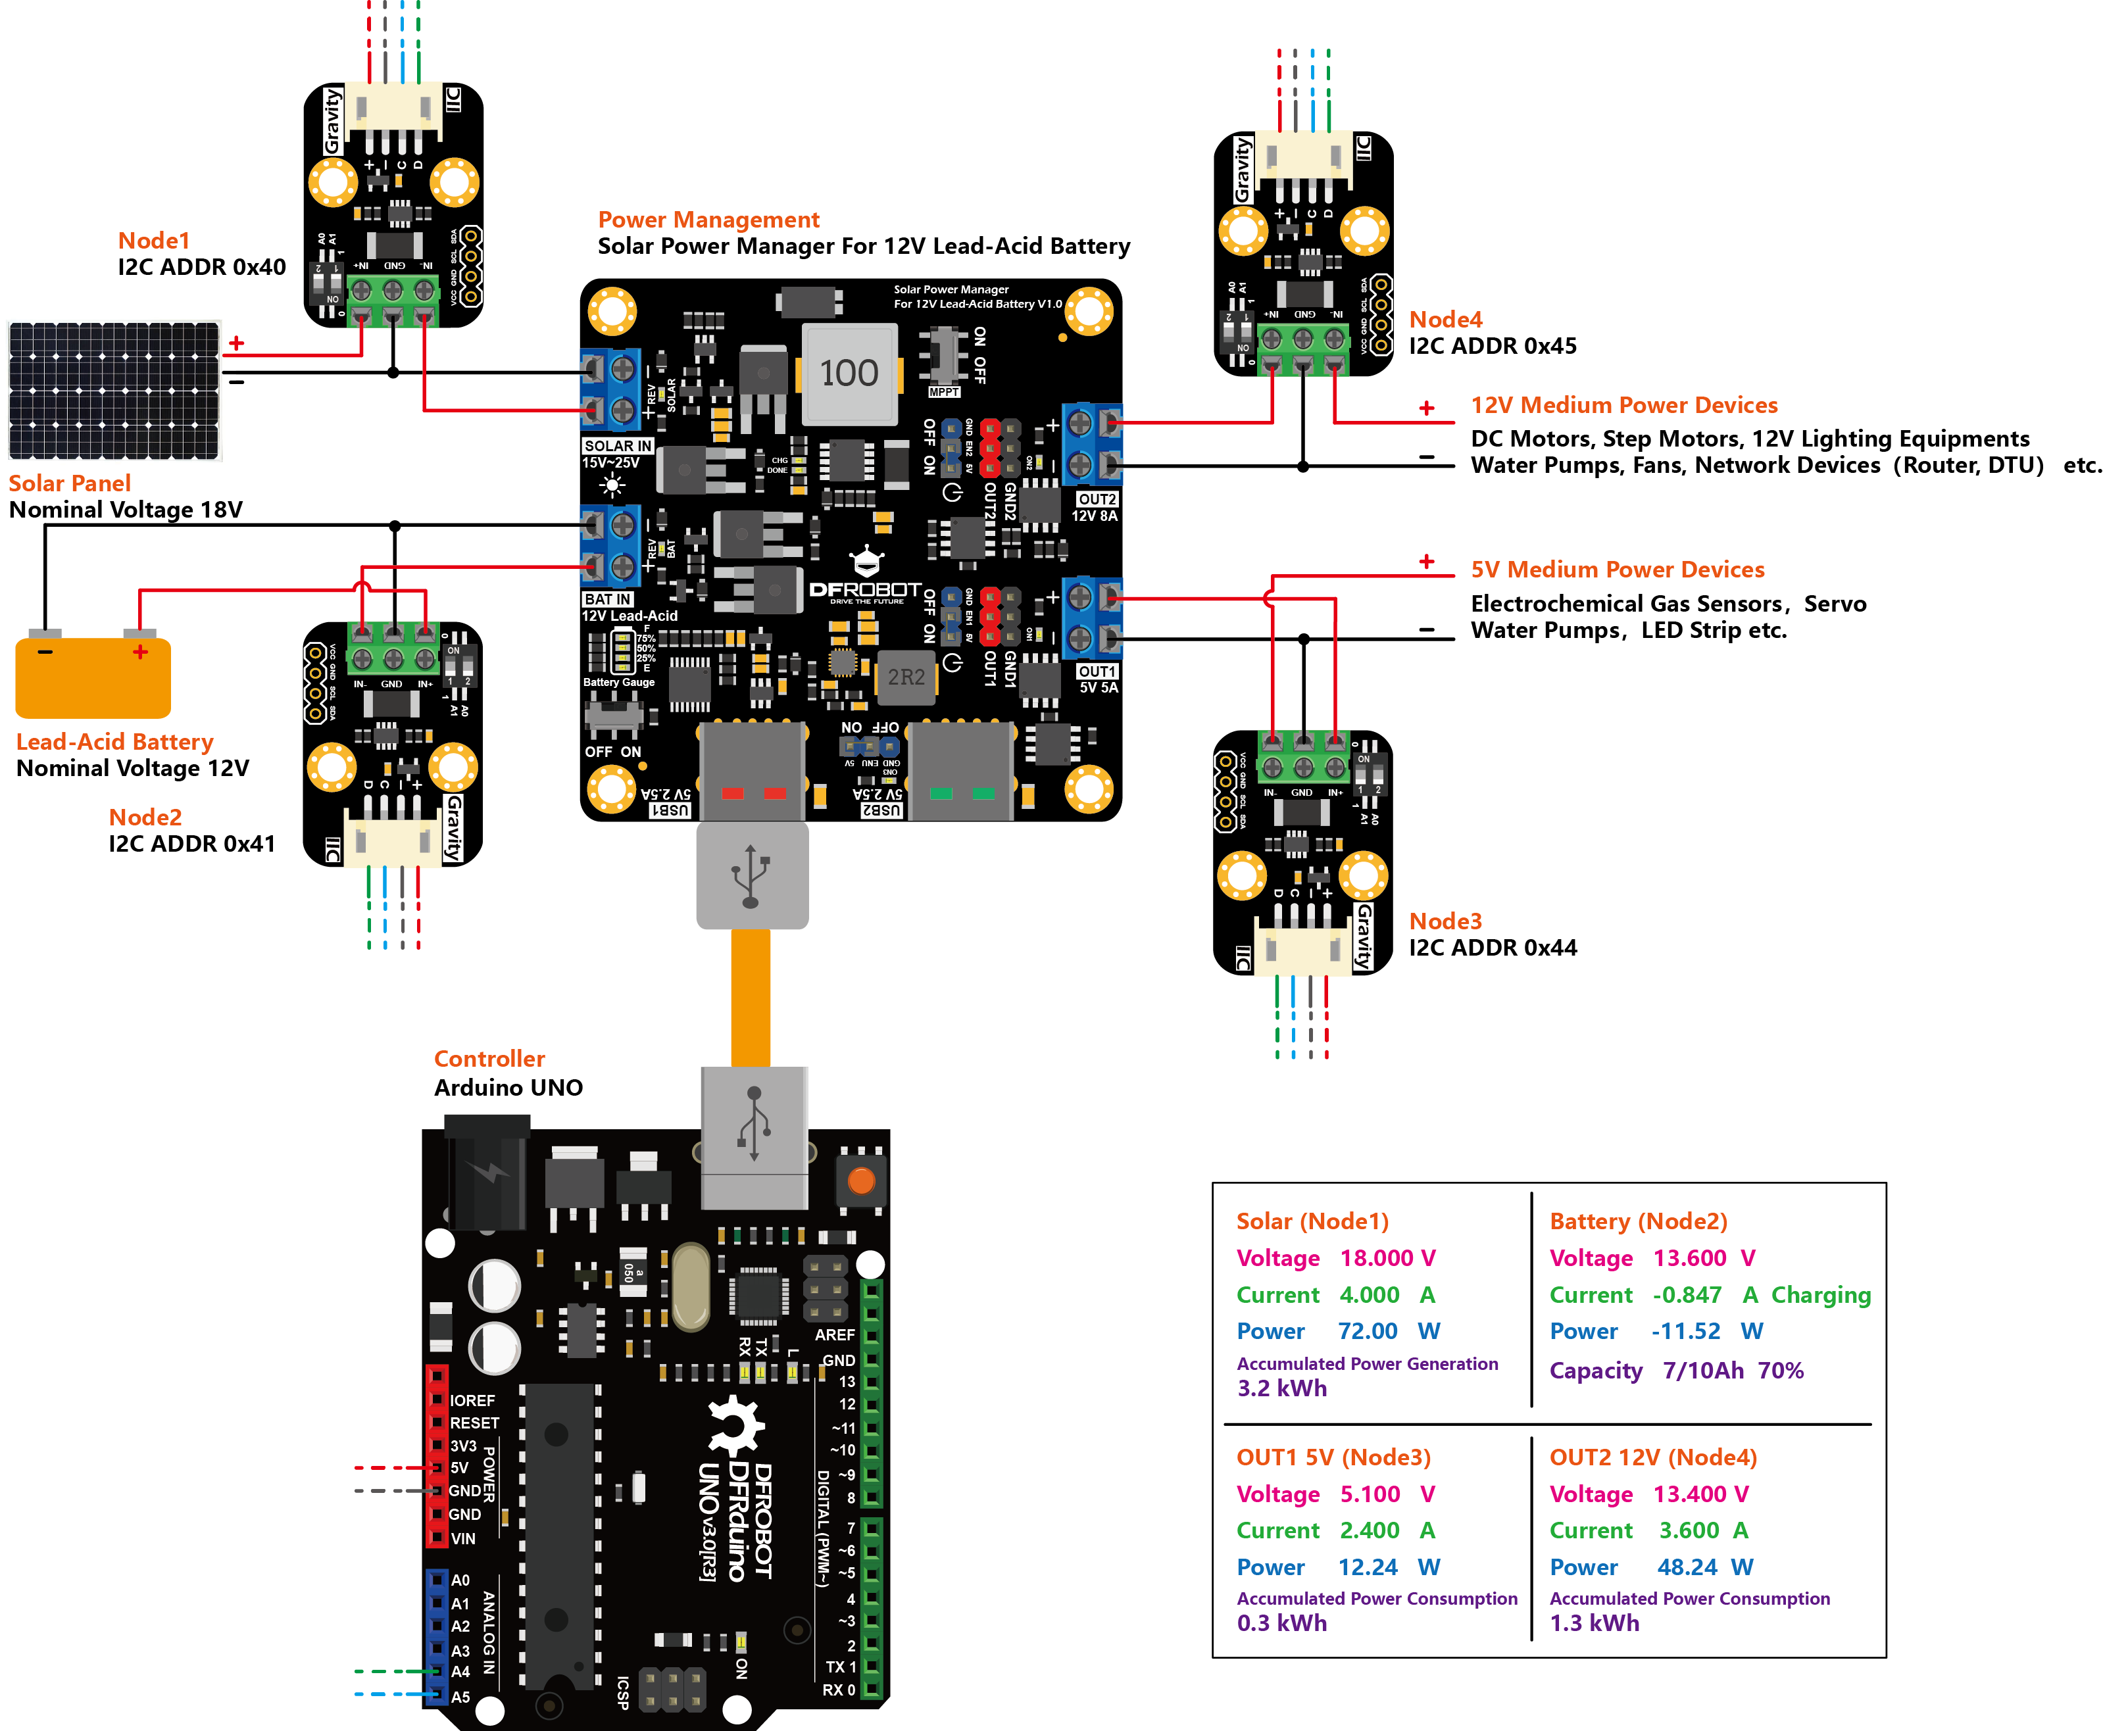

  - Current sensing on main battery
  - Current sensing on logic batter
  - Current sensing on Arduino power
  - Current sensing on RPIzero power
  - Current sensing on solar cell
  - Current sensing on motor power x4
  - Voltage sensing on main battery
  - Voltage sensing on RPIzero power
  - Voltage sensing on Arduino power
  - Voltage sensing on motor power x4

Experiments
- Implement a rug-edge detector with the LineTracker sensors
Connected the Arduino Uno to the Mac with a long enough cable so Serial window output could be used to monitor sensor outputs. Adjusted the sensitivity potentiometer so that when the three LEDs and sensors are over the rug they return a '1' on their digital inputs and on the hardware floor they return a '0'. A '1' indicates that there is not enough light to trigger the input (we are using the inverse of the digital input). At least one of the three sensors would be 1 as soon as the front of the vehicle was over the rug instead of the hardwood floor. Tested on two rugs.
- Implement a sensor data stream implementation of StayOnRug
  - In each loop
    - read digital inputs for FloorTexture, push to message stack with millis() time, mark the readings for the FloorTexture topic to imitate the eventual message bus
      - Use Arduino serial data transfer to listener process on RPIzero that listens on serial line for Prometheus formatted readings and publishes them to Mosquitto message bus mqtt/floortexture channel. Millis() since epoch are the time mark. See Prometheus doc on client libraries for specs of message standard.
      - https://gist.github.com/andypiper/1218932
      - https://5pi.de/2015/02/10/prometheus-on-raspberry-pi/
      - https://www.raspberrypi.org/forums/viewtopic.php?t=153385
    - read distance at direction i, push to message stack with millis() time, mark the readings for the DirectionDistanceN, one for each direction i, to imitate the eventual message bus
      - cycle through 8 directions of the ultrasonic sensor
      - consider including idle loop() instances so that all 8 direction distances are measured within some targeted repetition time
    - execute StayOnRug() that reads the digital inputs for FloorTexture and pushes primitive moves that create the StayOnRug behavior to the Actuator stack
    - execute Arbitrate() which, at this stage, will simply take the output of StayOnRug primitives on the message bus and pass them along to the Actuator functions. The priority of the behavior outputs is implemented as a table to guide Arbitrator to choose which Actuator values pushed to the message bus to pass on to the Actuators.
- Implement an Arbitrator as a neural network.
- Implement an Arbitrator as a neural network frontend to every Part.
- Implement behaviors for Avoiding, Escaping, Wandering, Seeking and Exploring controlling the action of the drive wheels.
- Implement behavior for Hunger to look for a power source for recharging.
- Implement a Strain-Pain-Part to signal that too much current is being drawn.
- Implement a Stuck-in-the-Mud Part to signal that Alan can't move.
If the Arbitrator is implemented as a table of priorities for behaviors, and if fundamental behaviors with parameters can be combined into behavior sequences, then when a behavior is not reaching its goal, or Alan detects that he’s stuck, he can look for alternative behaviors, and eventually add the alternatives into the Arbitrator table. The Arbitrator in Mobile Robots doesn’t have the capacity for allowing multiple behaviors to be triggered at the same priority, but it’s an interesting Experiment to add that capability.

